Day 7

**C++ Inheritance**

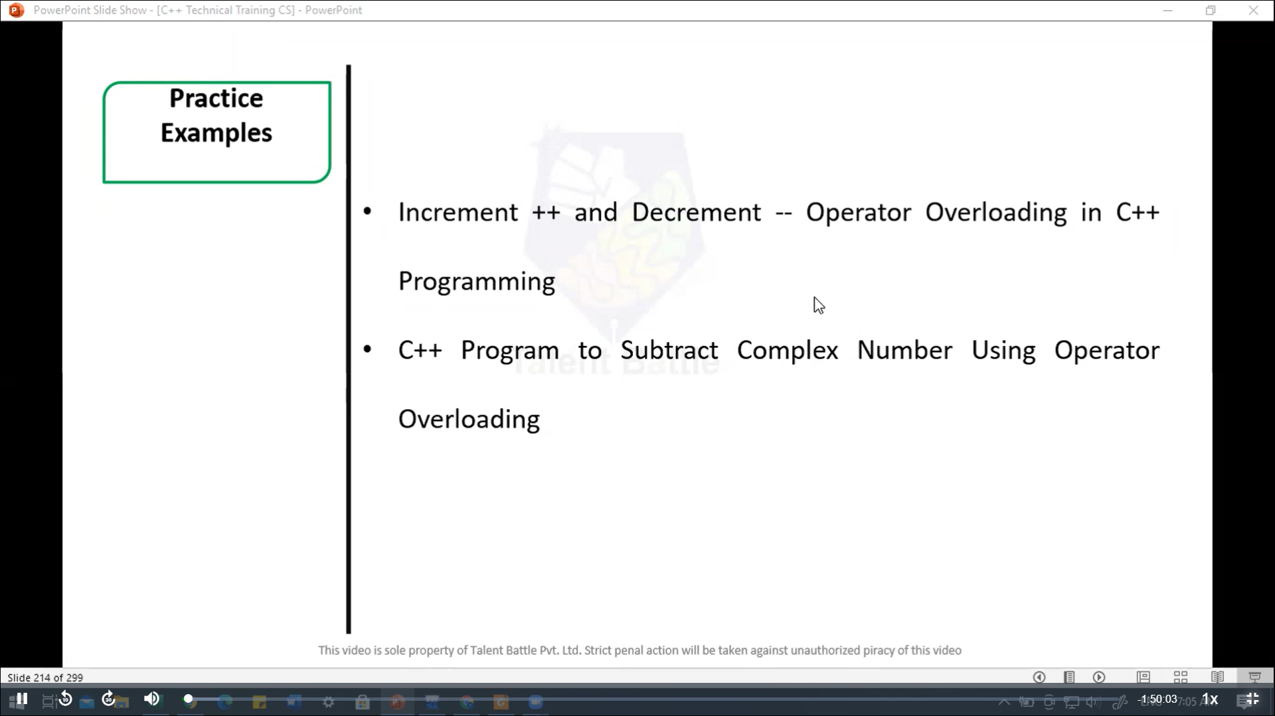

#include <iostream>

using namespace ***std***;

*class* MyClass {

  private***:***

    int value;

  public***:***

*MyClass*() ***:*** *value*(0){}

    // Prefic increment

    MyClass& operator***++***(){

      ++value;

      return *this;

    }

    // Postfix increment

    MyClass operator***++*** (int){

      MyClass temp = *this;

      ++value;

      return temp;

    }

    // Prefix decrement

    MyClass& operator***--*** (){

      --value;

      return *this;

    }

    // Postfix decrement

    MyClass operator***--***(int){

      MyClass temp = *this;

      --value;

      return temp;

    }

    void *display*() const {

       cout ***<<*** "Value: " ***<<*** value ***<<*** endl;

    }

};

int *main*(){

  MyClass obj;

  cout ***<<*** "Initial ";

  obj***.****display*();

  cout ***<<*** "After prefix increment ";

  ++obj;

  obj***.****display*();

  cout ***<<*** "After postfix increment ";

  obj++;

  obj***.****display*();

  cout ***<<*** "After prefix decrement ";

  --obj;

  obj***.****display*();

  cout ***<<*** "After postfix decrement ";

  obj--;

  obj***.****display*();

  return 0;

}

/*

Initial Value: 0

After prefix increment Value: 1

After postfix increment Value: 2

After prefix decrement Value: 1

After postfix decrement Value: 0

--------------------------------

Process exited after 0.1404 seconds with return value 0

*/

//======================================================

#include <iostream>

*class* Complex {

private***:***

    double real;

    double imag;

public***:***

    // Constructor

*Complex*(double ***r*** = 0***,*** double ***i*** = 0) ***:*** real(***r***)***,*** imag(***i***) {}

    // Overloading the - operator

    Complex *operator-*(const Complex& ***other***) const {

        return Complex(real - ***other.***real***,*** imag - ***other.***imag);

    }

    // Display function

    void *display*() const {

***std::***cout *<<* real *<<* " + " *<<* imag *<<* "i" *<<* ***std::****endl*;

    }

};

int *main*() {

    double real1***,*** imag1***,*** real2***,*** imag2;

***std::***cout *<<* "Enter real and imaginary part of the first complex number: ";

***std::***cin *>>* real1 *>>* imag1;

***std::***cout *<<* "Enter real and imaginary part of the second complex number: ";

***std::***cin *>>* real2 *>>* imag2;

    Complex c1(real1***,*** imag1);

    Complex c2(real2***,*** imag2);

    Complex c3 = c1 *-* c2;

***std::***cout *<<* "Result of subtraction: ";

    c3***.****display*();

    return 0;

}

/*

Enter real and imaginary part of the first complex number: 4

3

Enter real and imaginary part of the second complex number: 6

5

Result of subtraction: -2 + -2i

--------------------------------

Process exited after 4.799 seconds with return value 0

Press any key to continue . . .

*/

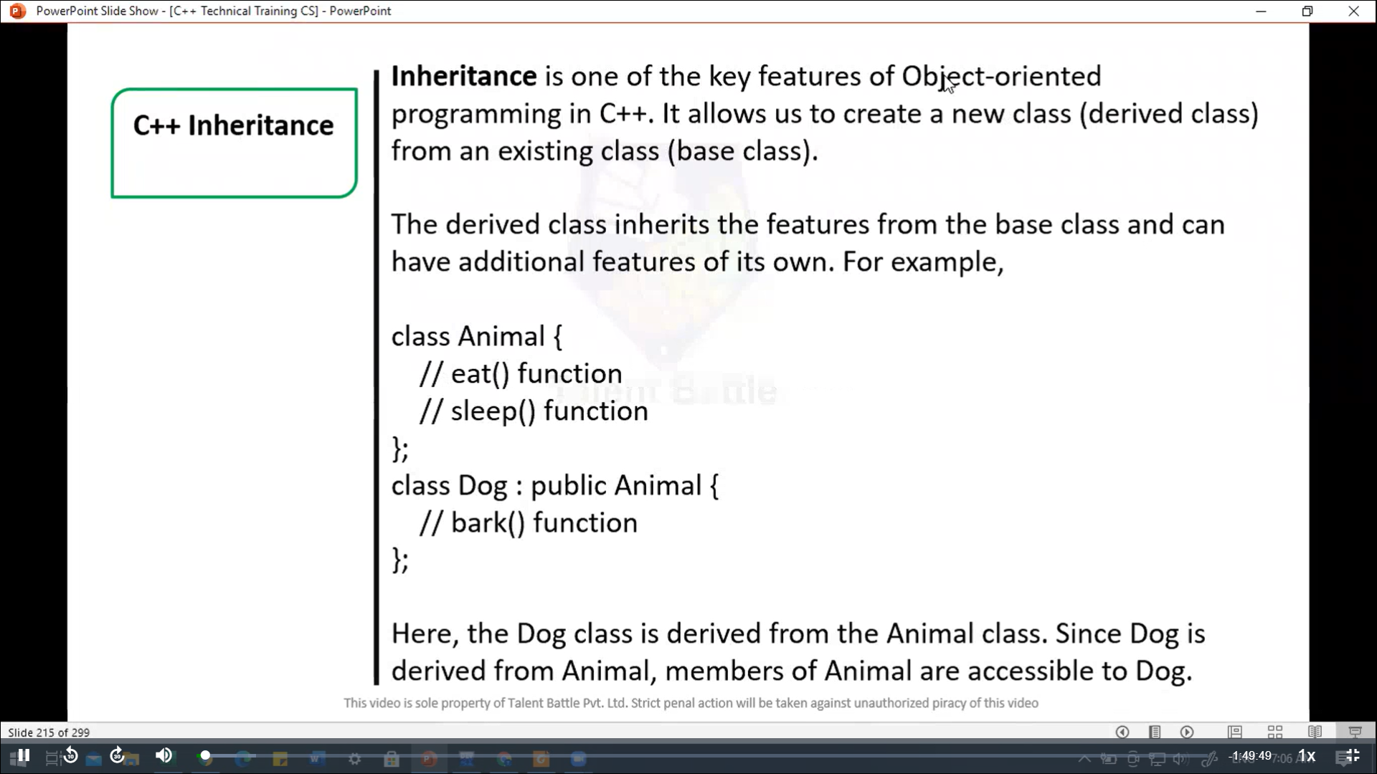

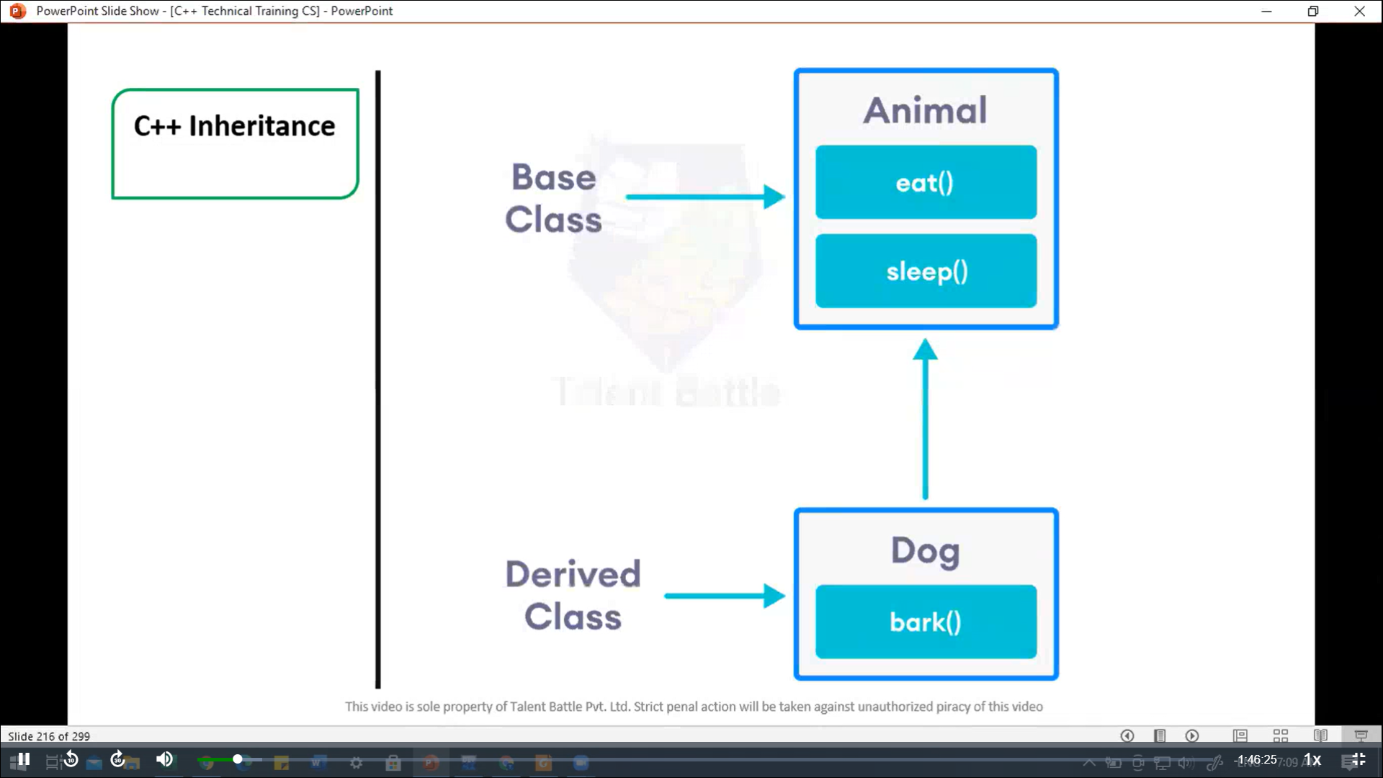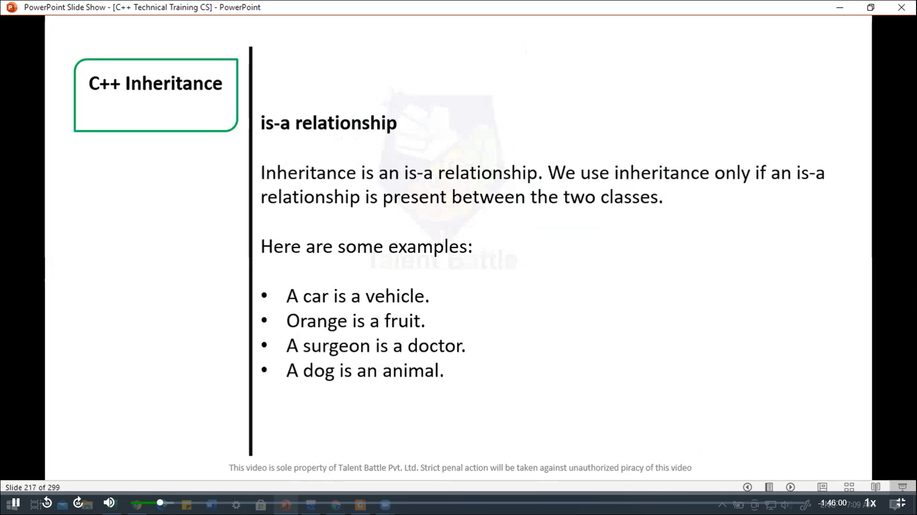

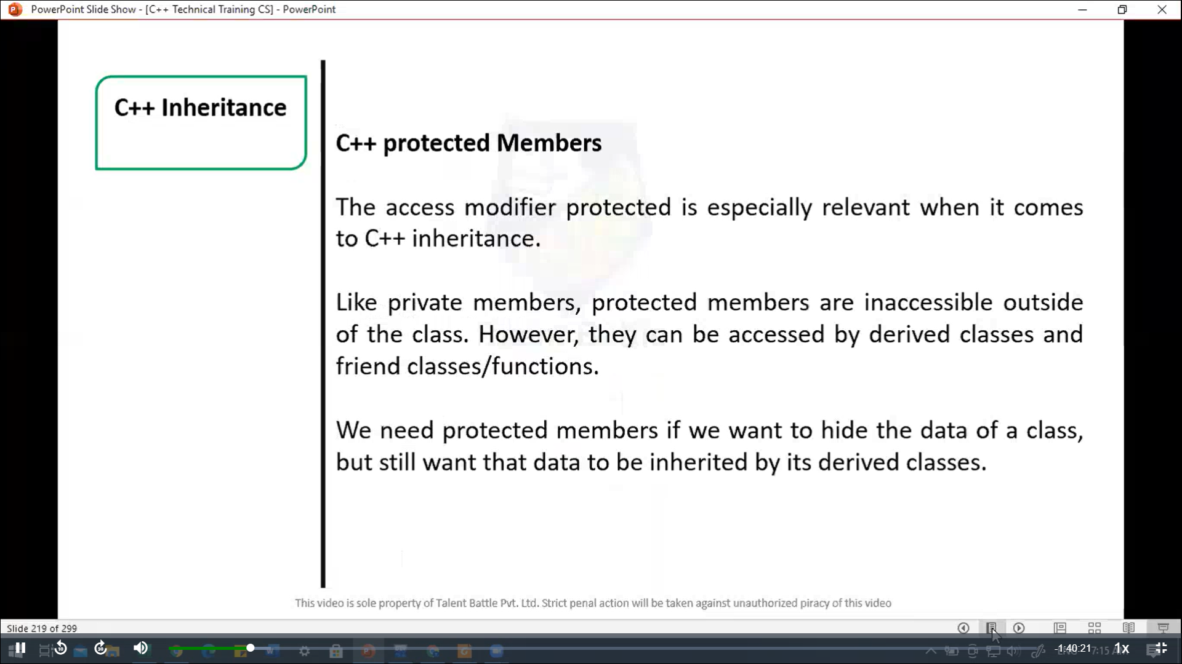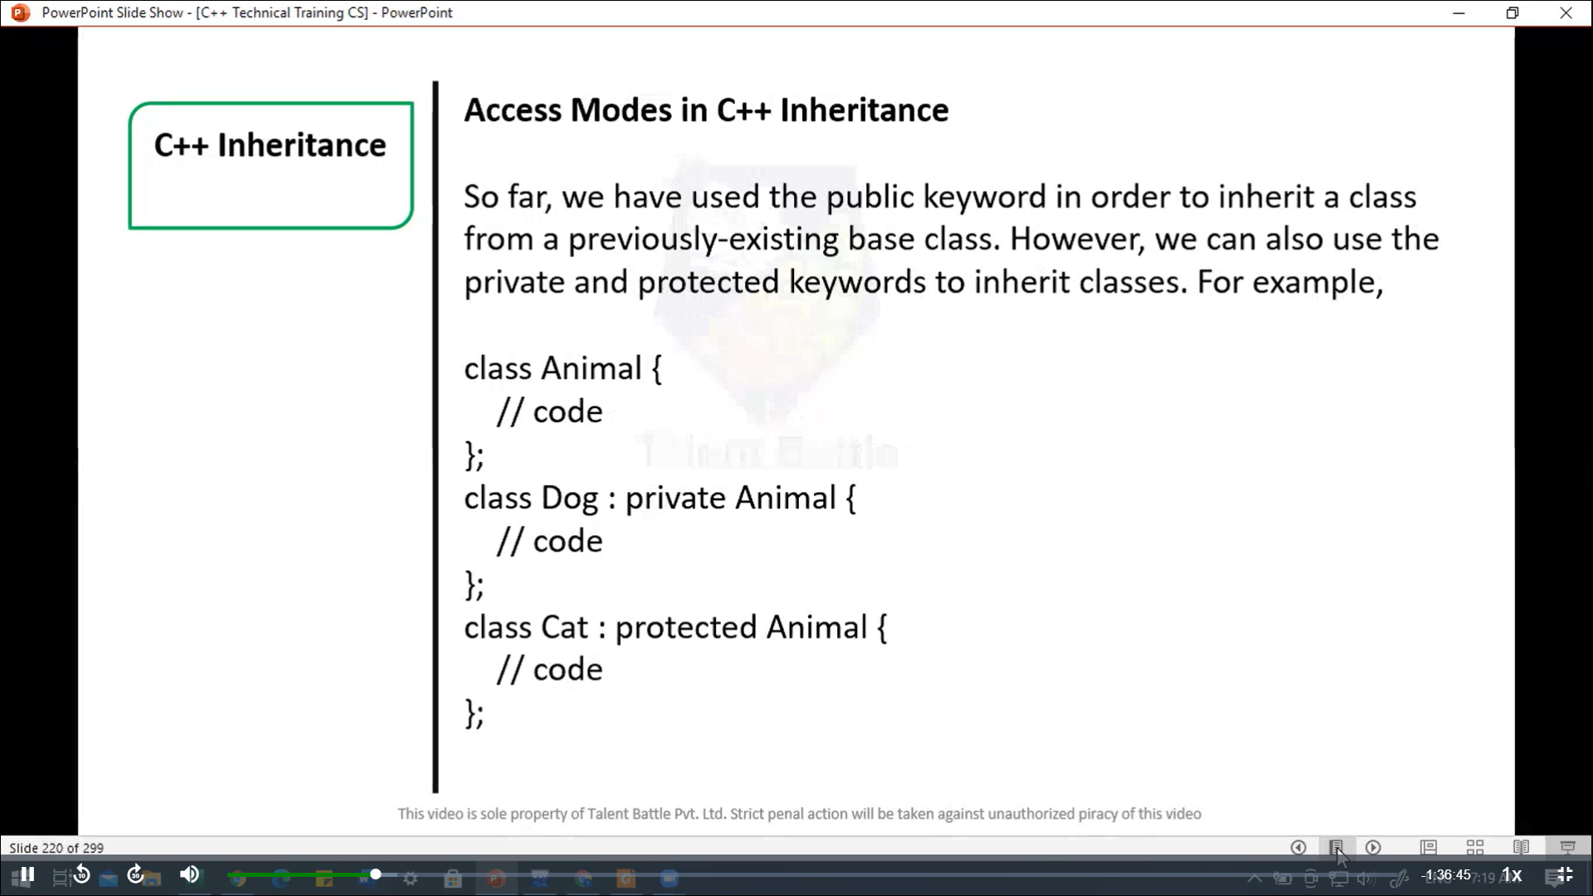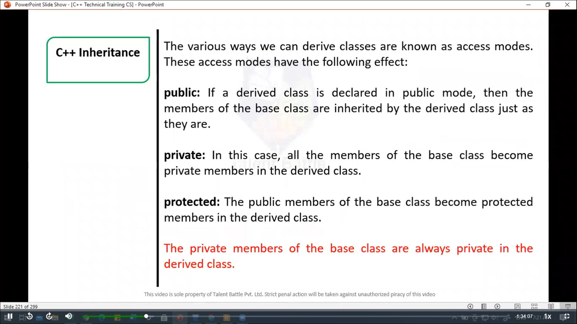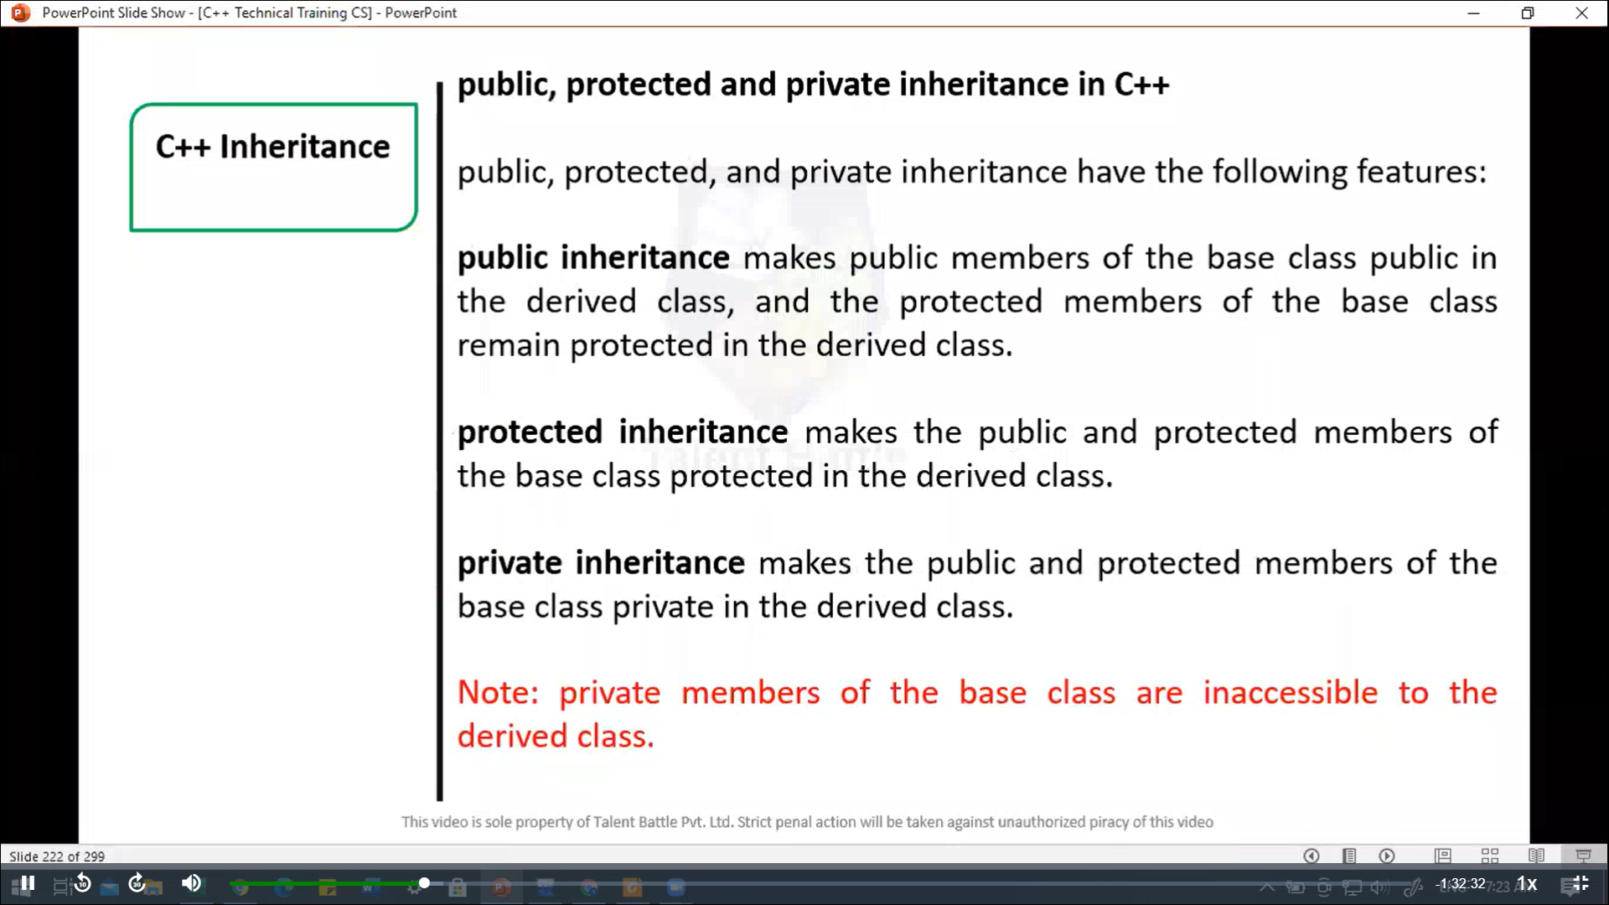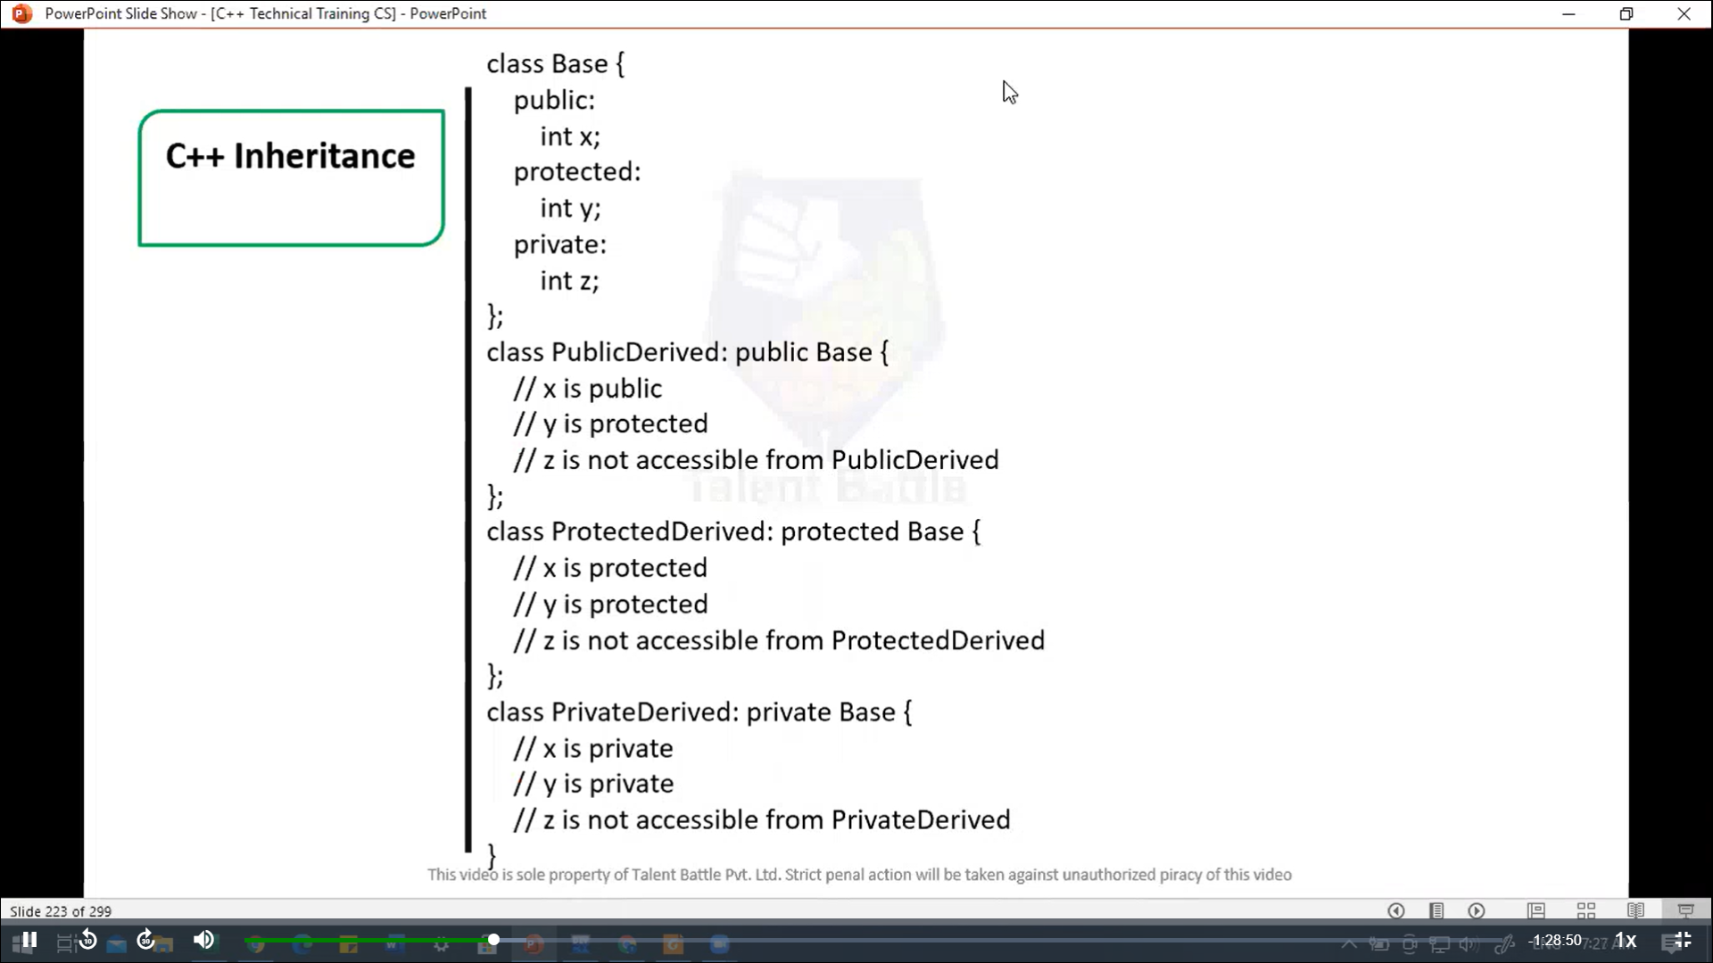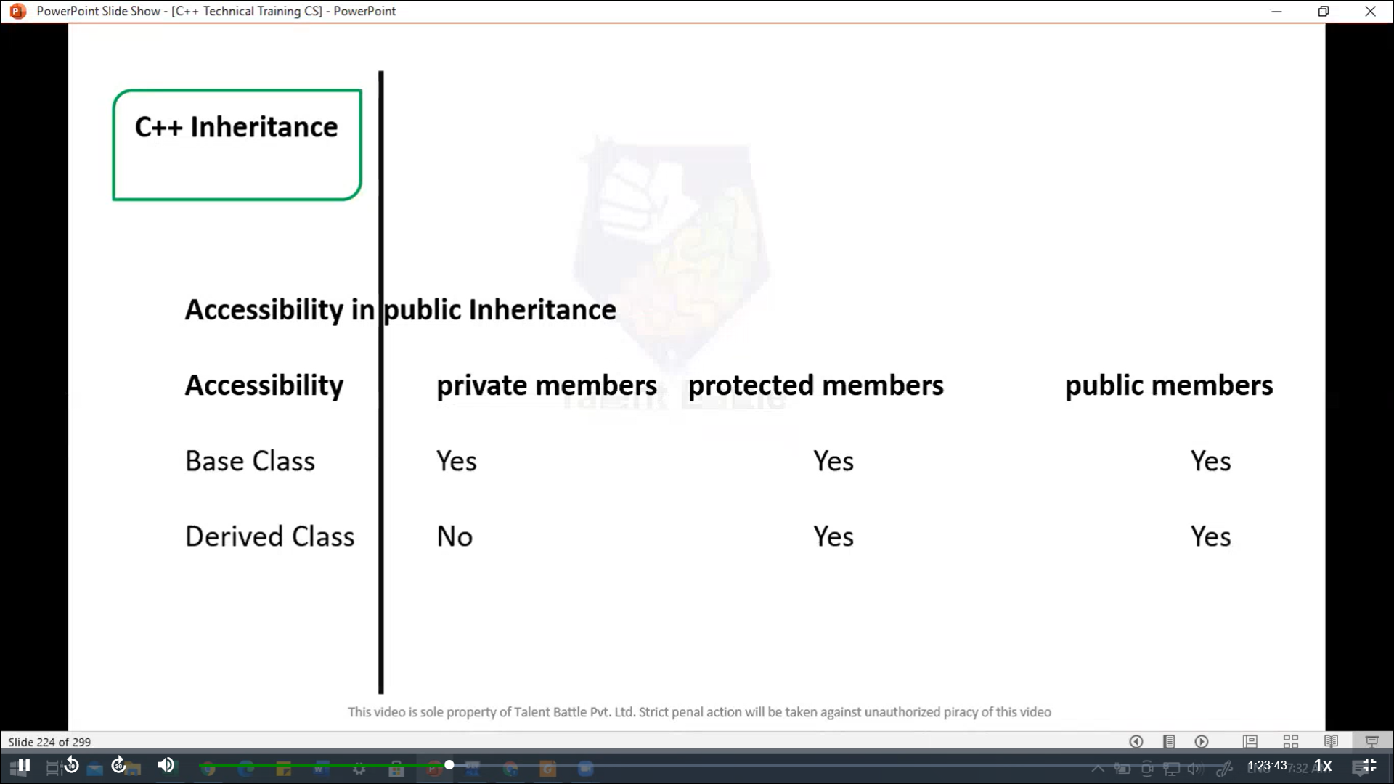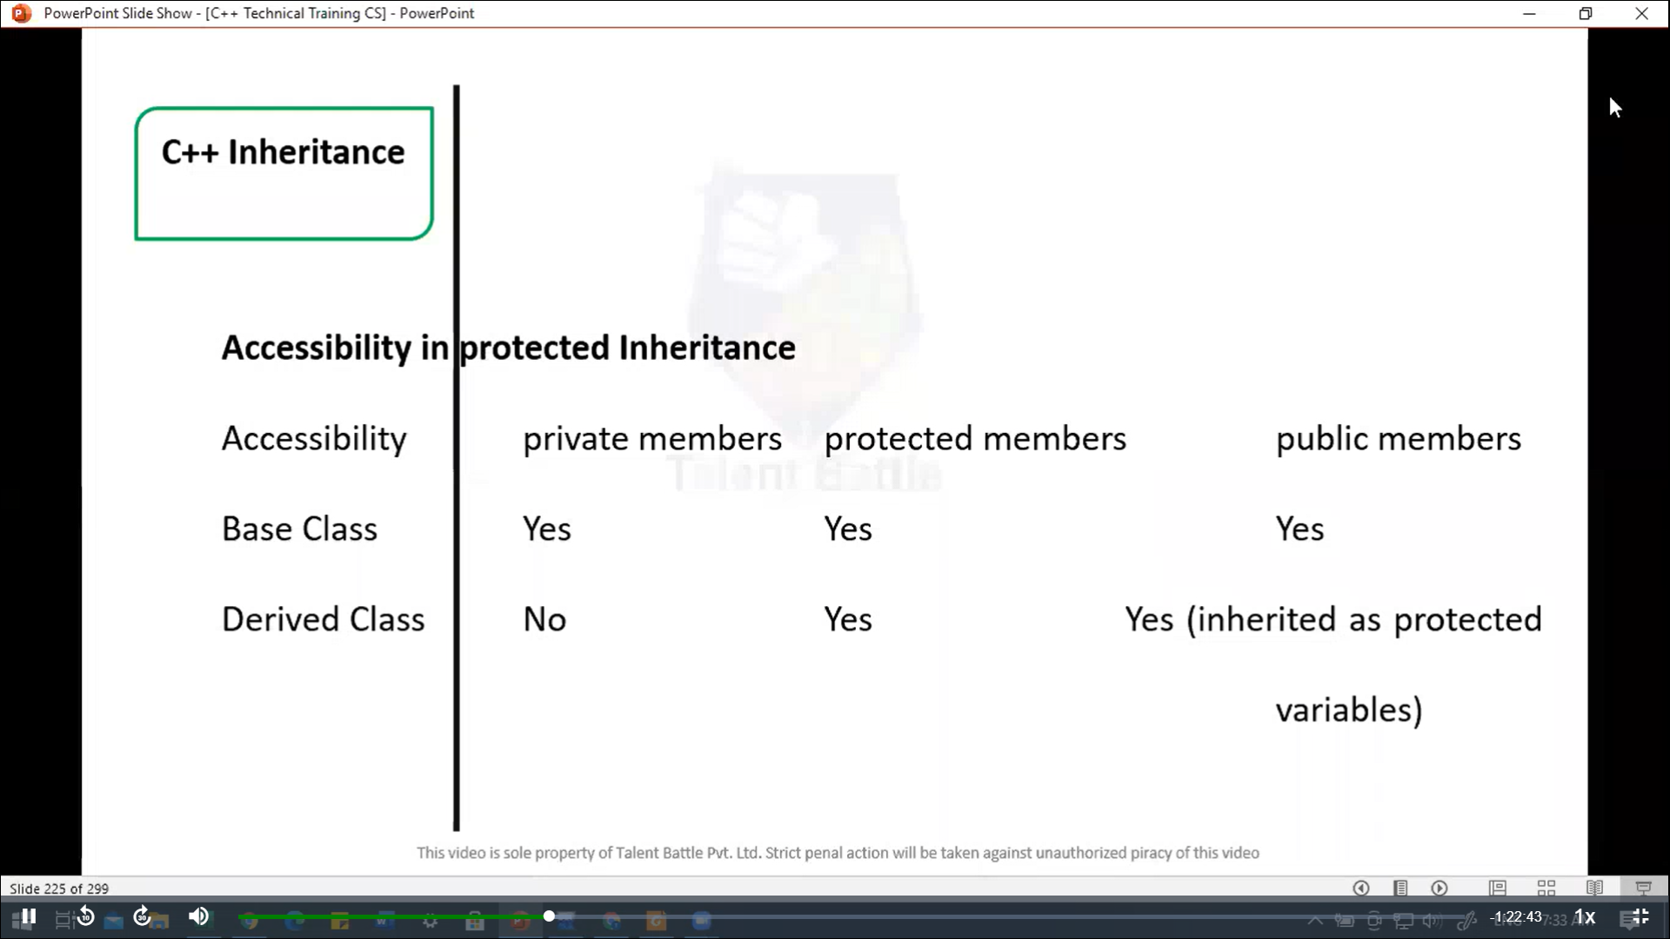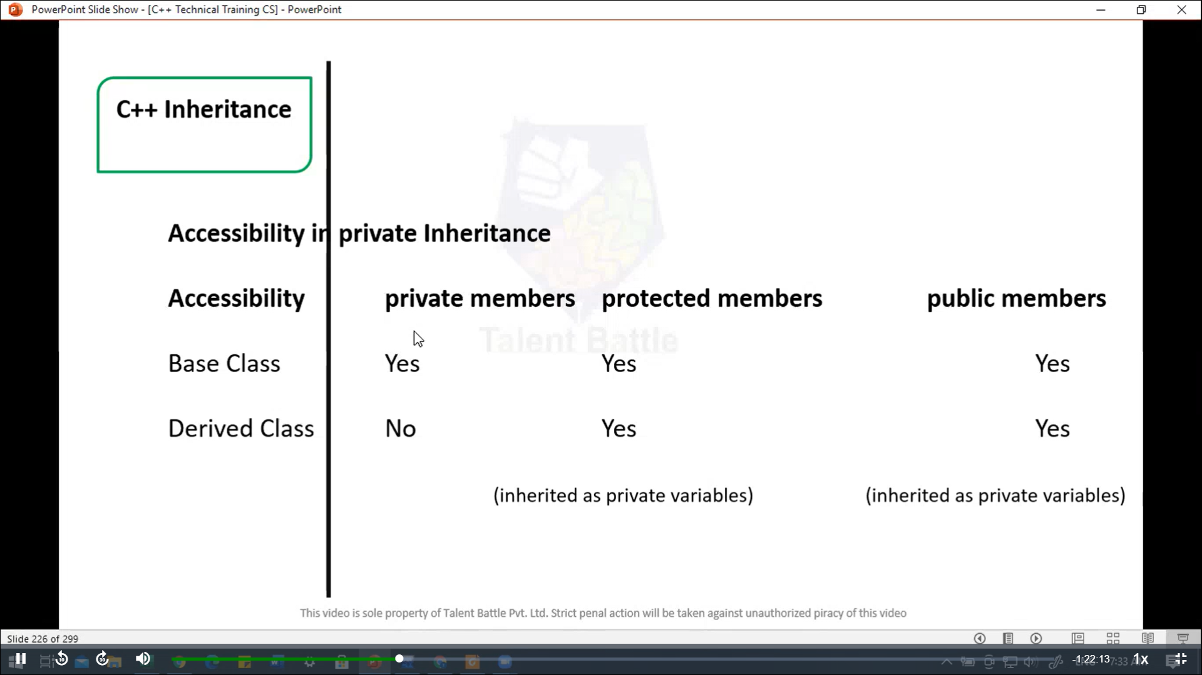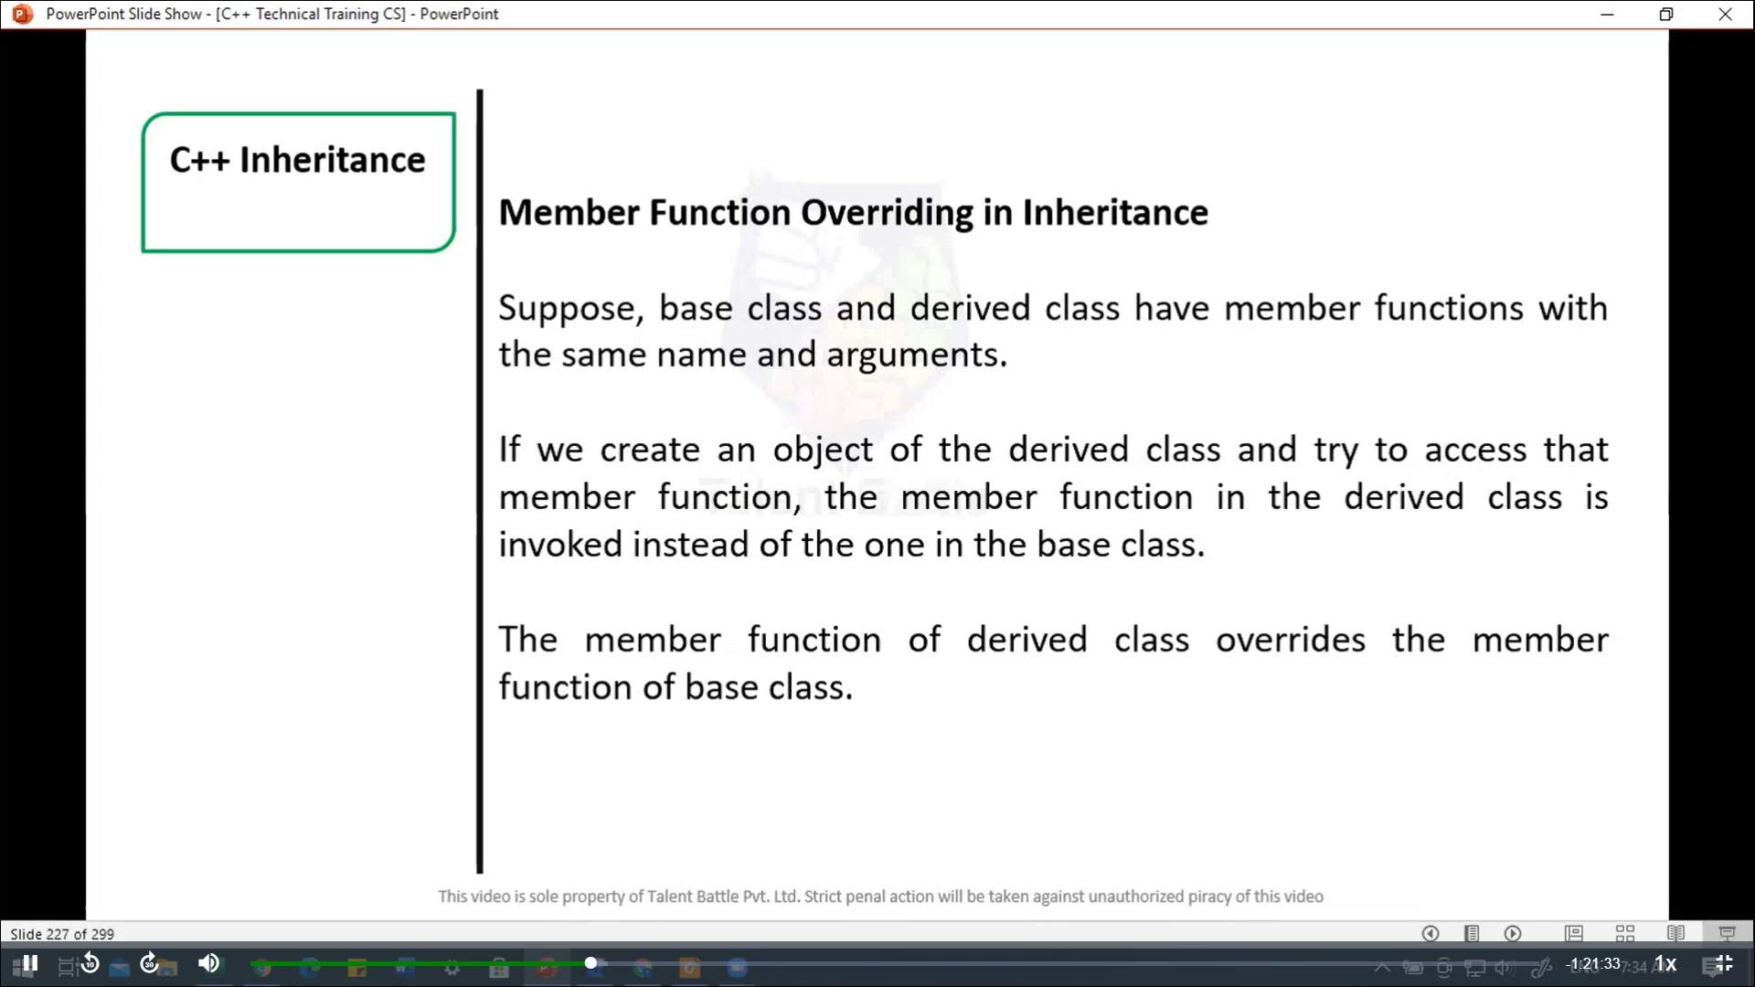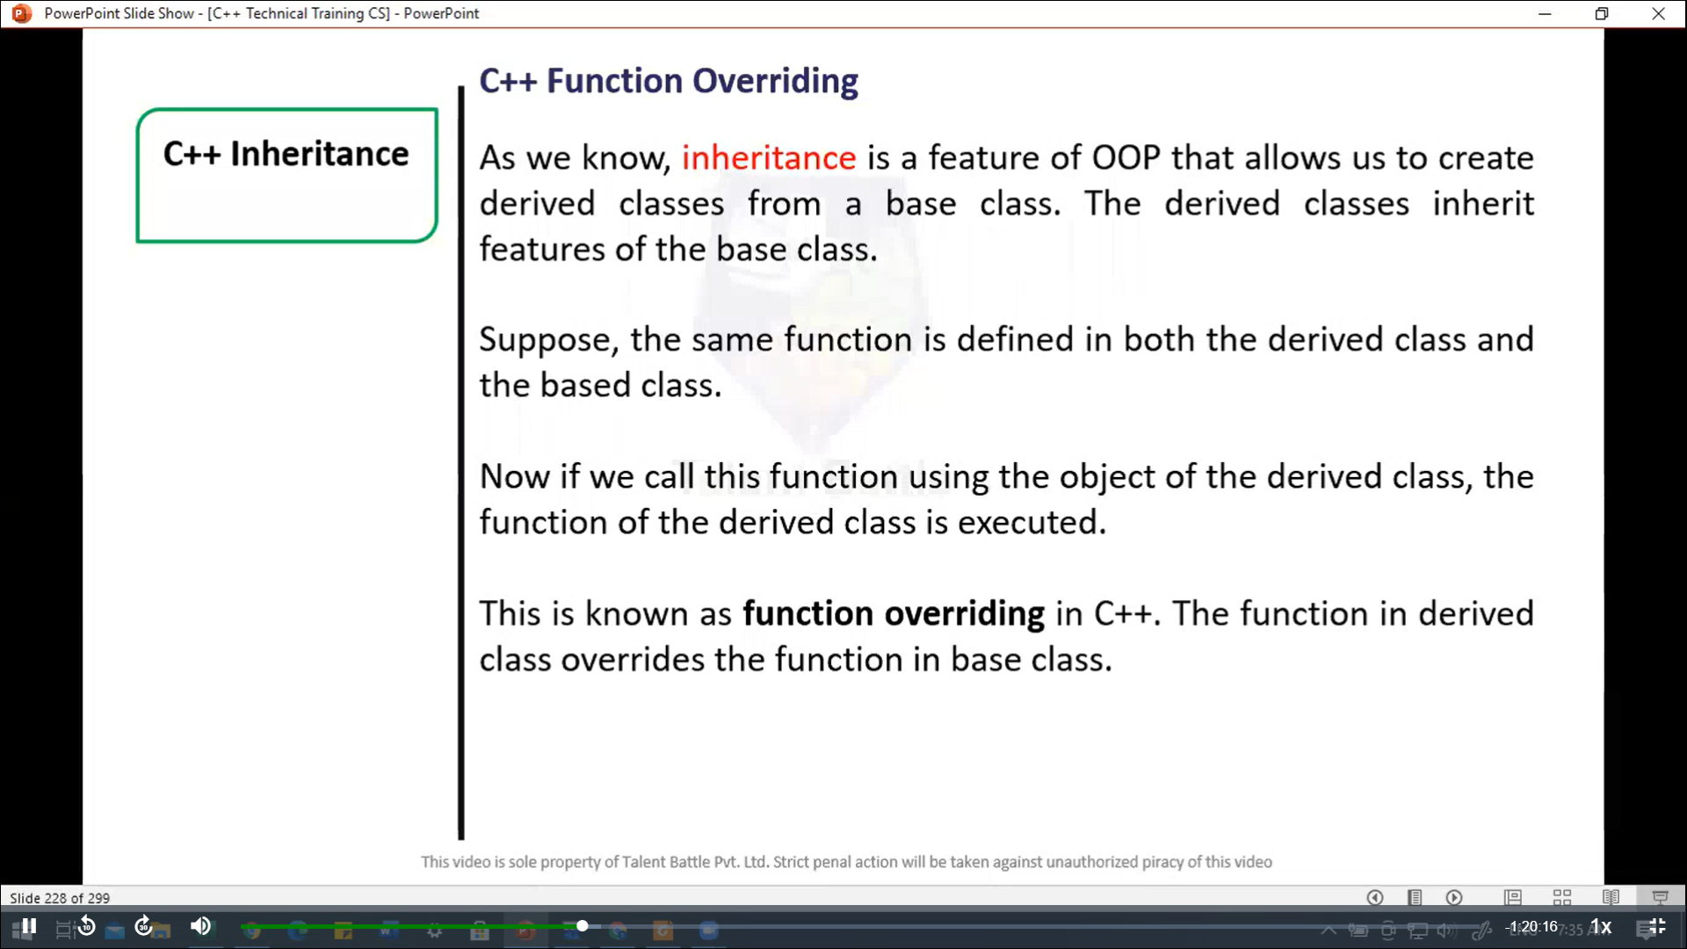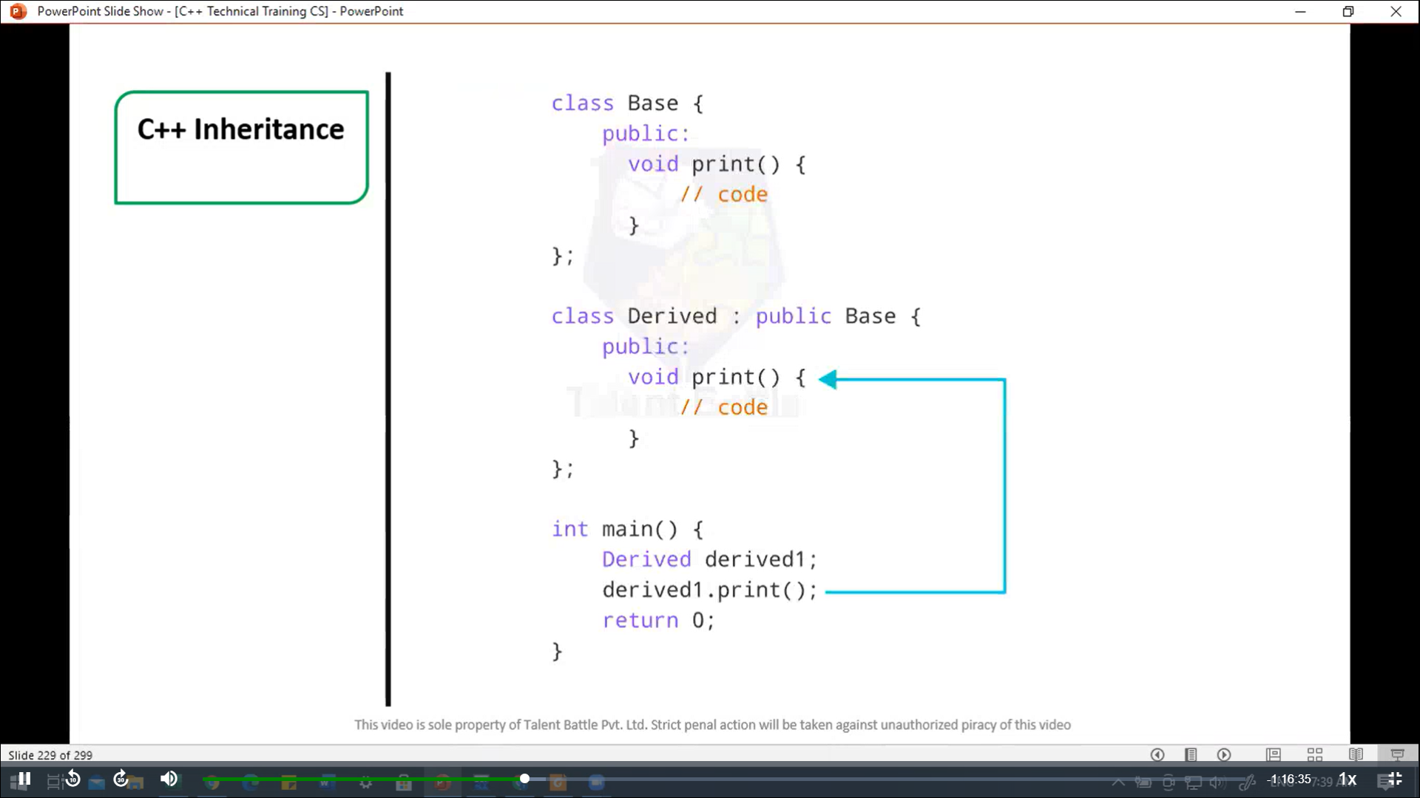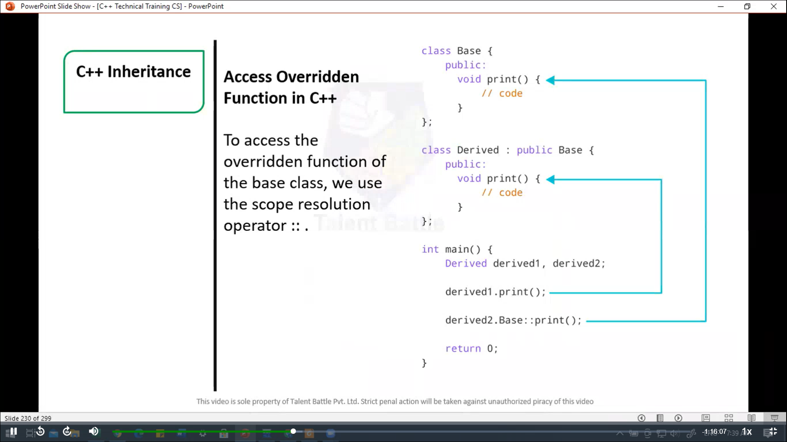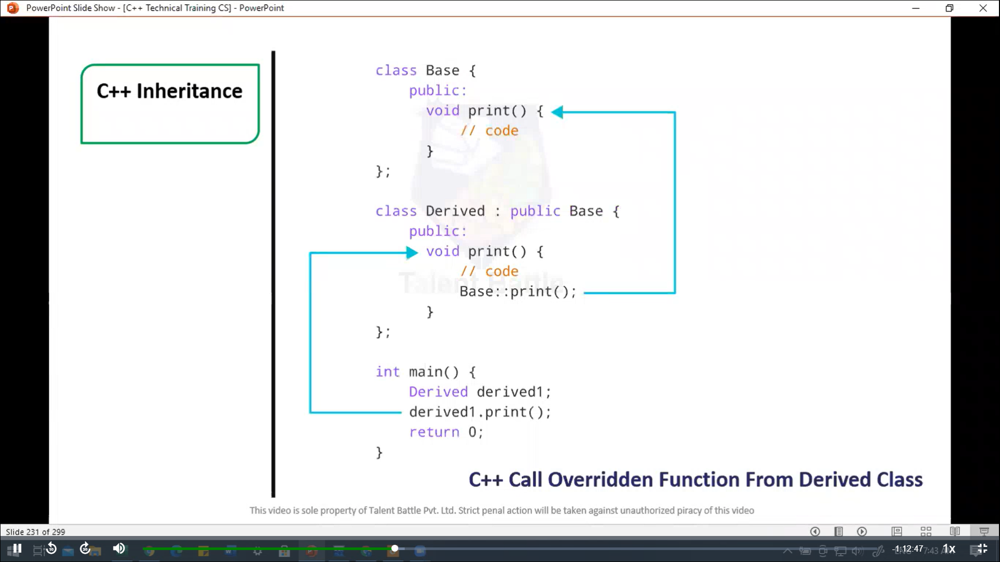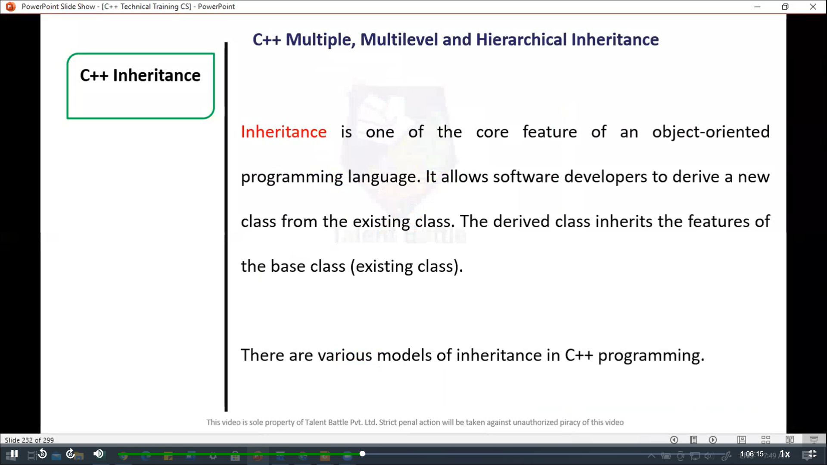

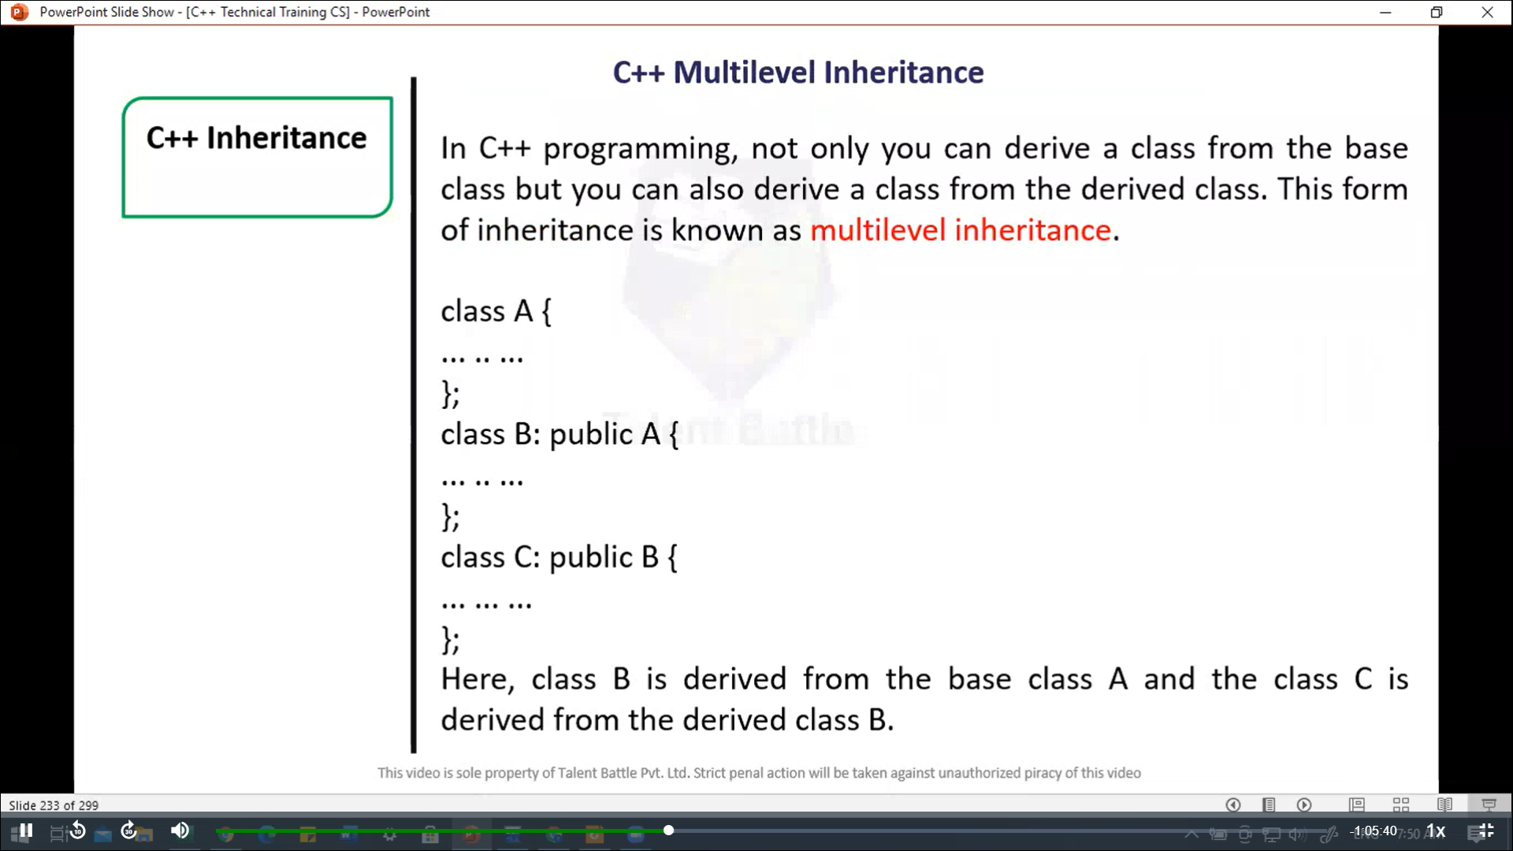

//=======================================================

// C++ Inheritance

// C++ program to demonstrate inheritance

/*

#include<iostream>

using namespace std;

// base class

class Animal{

  public:

    void eat(){

      cout << "I can eat!" << endl;

    }

    void sleep(){

      cout << "I can sleep!" << endl;

    }

};

// derived class

class Dog : public Animal{

  public:

    void bark(){

      cout << "I can bark! Woof woof!!" << endl;

    }

};

int main(){

  // Create object of the Dog class

  Dog dog1;

  // Calling members of the base class

  dog1.eat();

  dog1.sleep();

  // Calling member of the derived class

  dog1.bark();

  return 0;

}

*/

/*

I can eat!

I can sleep!

I can bark! Woof woof!!

--------------------------------

Process exited after 0.06775 seconds with return value 0

*/

//==============================================

// C++ Inheritance

// Multi-level inheritance

/*

#include <iostream>

using namespace std;

class A{

  public:

    void display(){

      cout << "Base class content.";

    }

};

class B :  public A{};

class C : public B{};

int main(){

  C obj;

  obj.display();

  return 0;

}

*/

/*

Base class content.

--------------------------------

Process exited after 0.1374 seconds with return value 0

*/

//================================================

#include<iostream>

using namespace ***std***;

*class* A;

*class* B{

  public***:***

    int  a;

    void *getdata*(int ***n***){

      a = ***n***;

    }

    friend int *sum*(A***,*** B);

};

*class* A{

  public***:***

    int b;

    void *getdata*(int ***m***){

      b = ***m***;

    }

    friend int *sum*(A***,*** B);

};

int *sum*(A ***m,*** B ***n***){

  int result;

  result = ***m.***b + ***n.***a;

  return result;

}

int *main*(){

  B obj1;

  A obj2;

  obj2***.****getdata*(10);

  obj1***.****getdata*(20);

  cout *<<* "Result of sum = " *<<* *sum*(obj2***,*** obj1);

  return 0;

}

/*

Result of sum = 30

--------------------------------

Process exited after 0.1154 seconds with return value 0

Press any key to continue . . .

*/

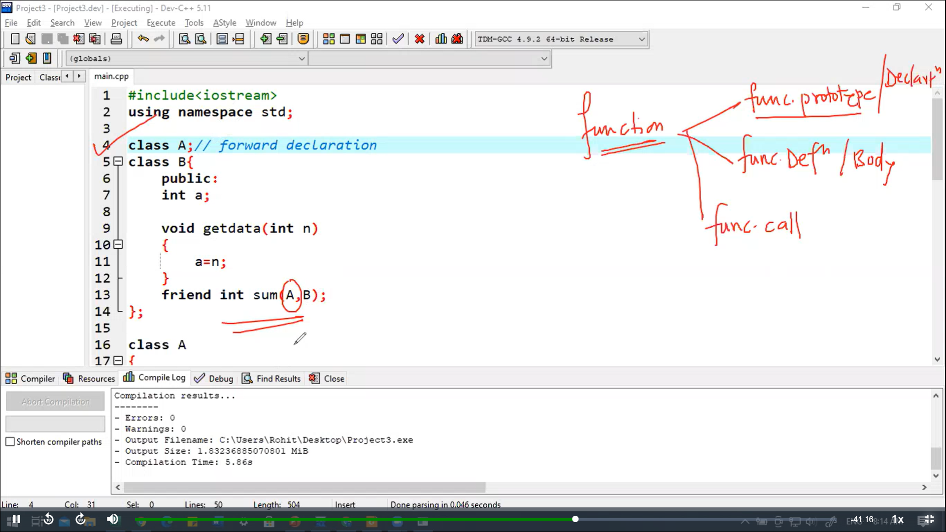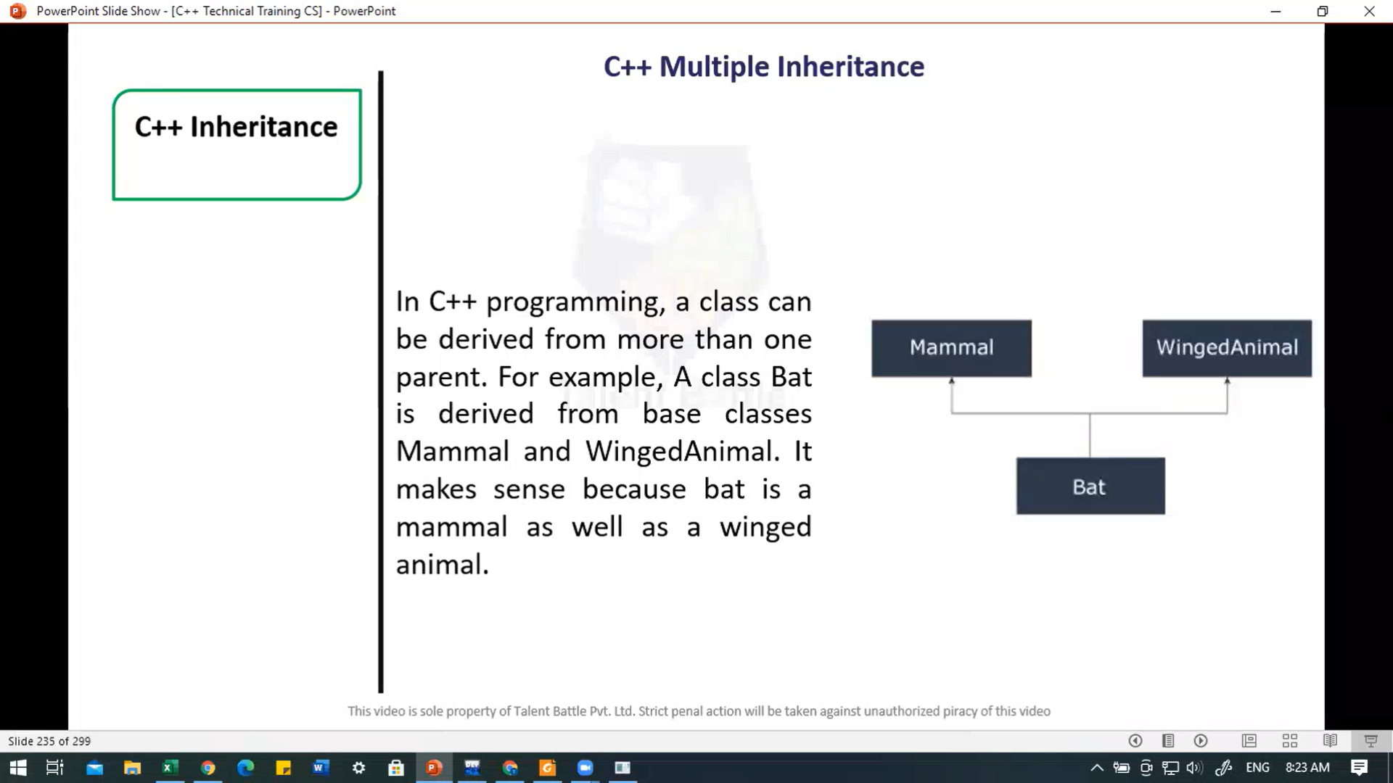

//============================================

// Multiple Inheritance

#include<iostream>

using namespace ***std***;

*class* Mammal{

  public***:***

*Mammal*(){

      cout *<<* "Mammals can give direct birth." *<<* *endl*;

    }

};

*class* WingedAnimal{

  public***:***

*WingedAnimal*(){

      cout *<<* "Winged animal can flap." *<<* *endl*;

    }

};

*class* Bat***:*** public Mammal***,*** public WingedAnimal{};

int *main*(){

  Bat b1;

  return 0;

}

/*

Mammals can give direct birth.

Winged animal can flap.

--------------------------------

Process exited after 0.1364 seconds with return value 0

*/

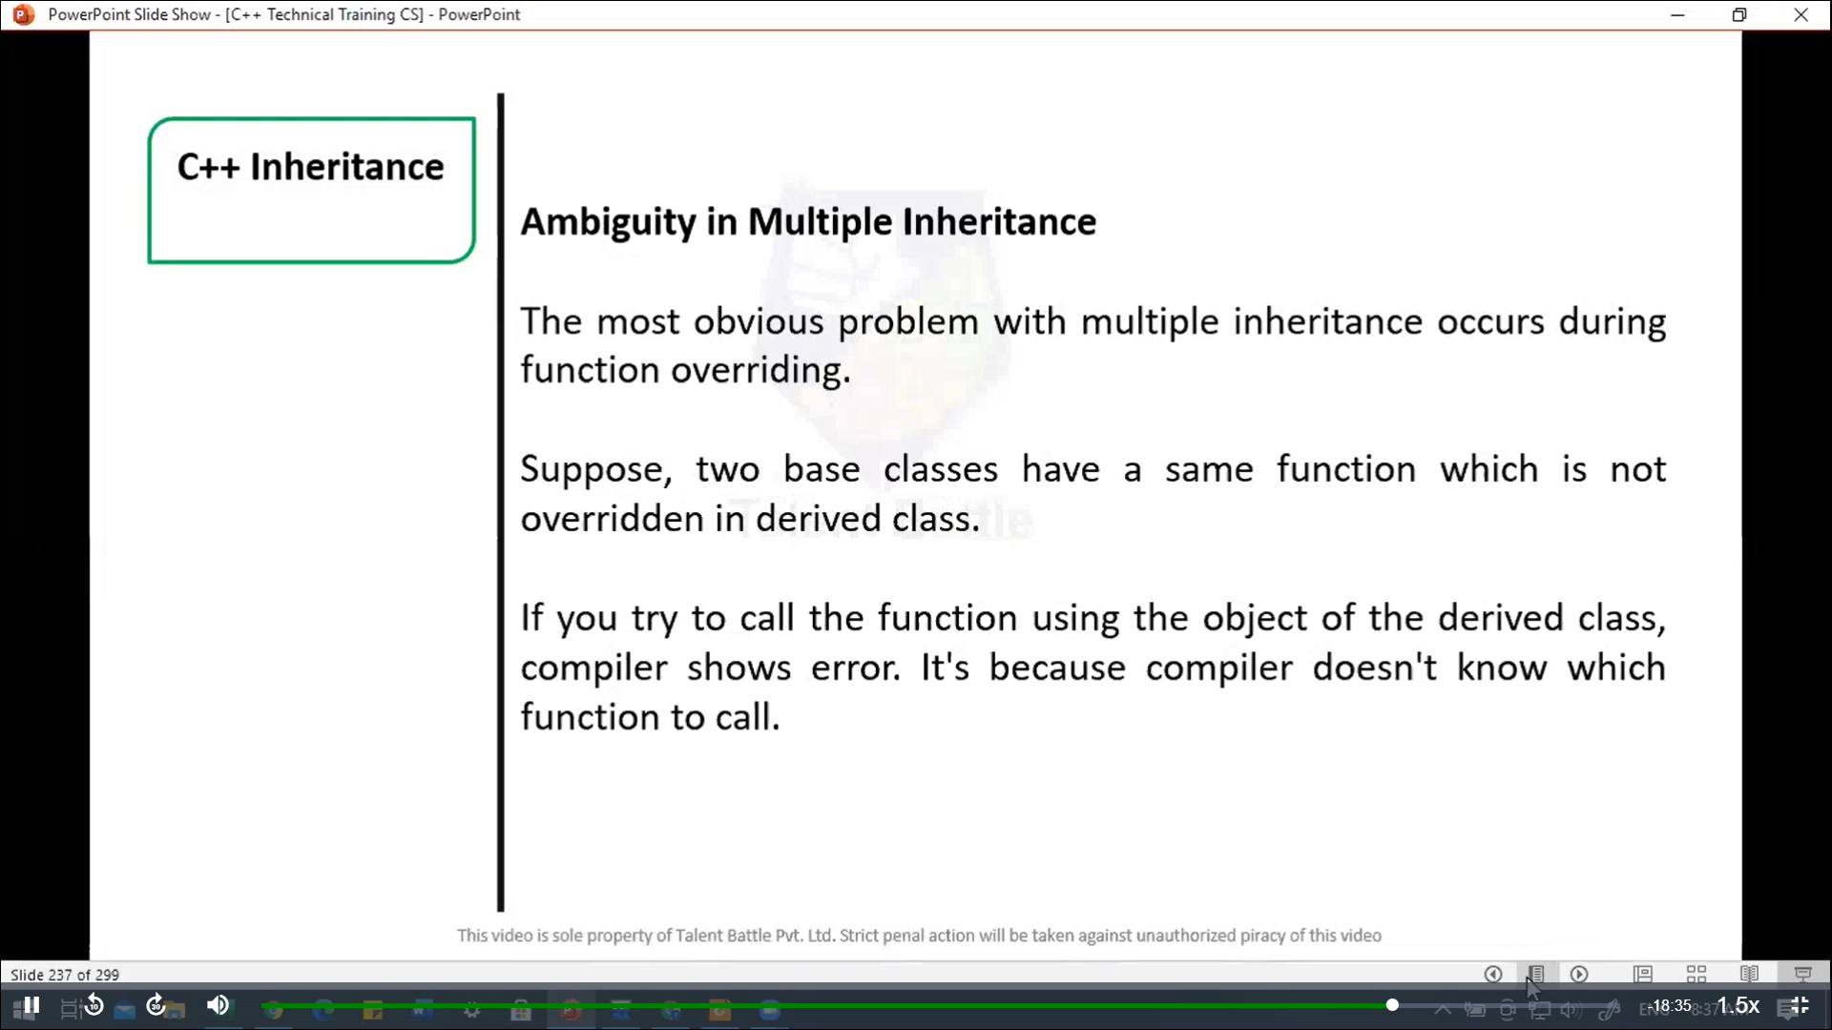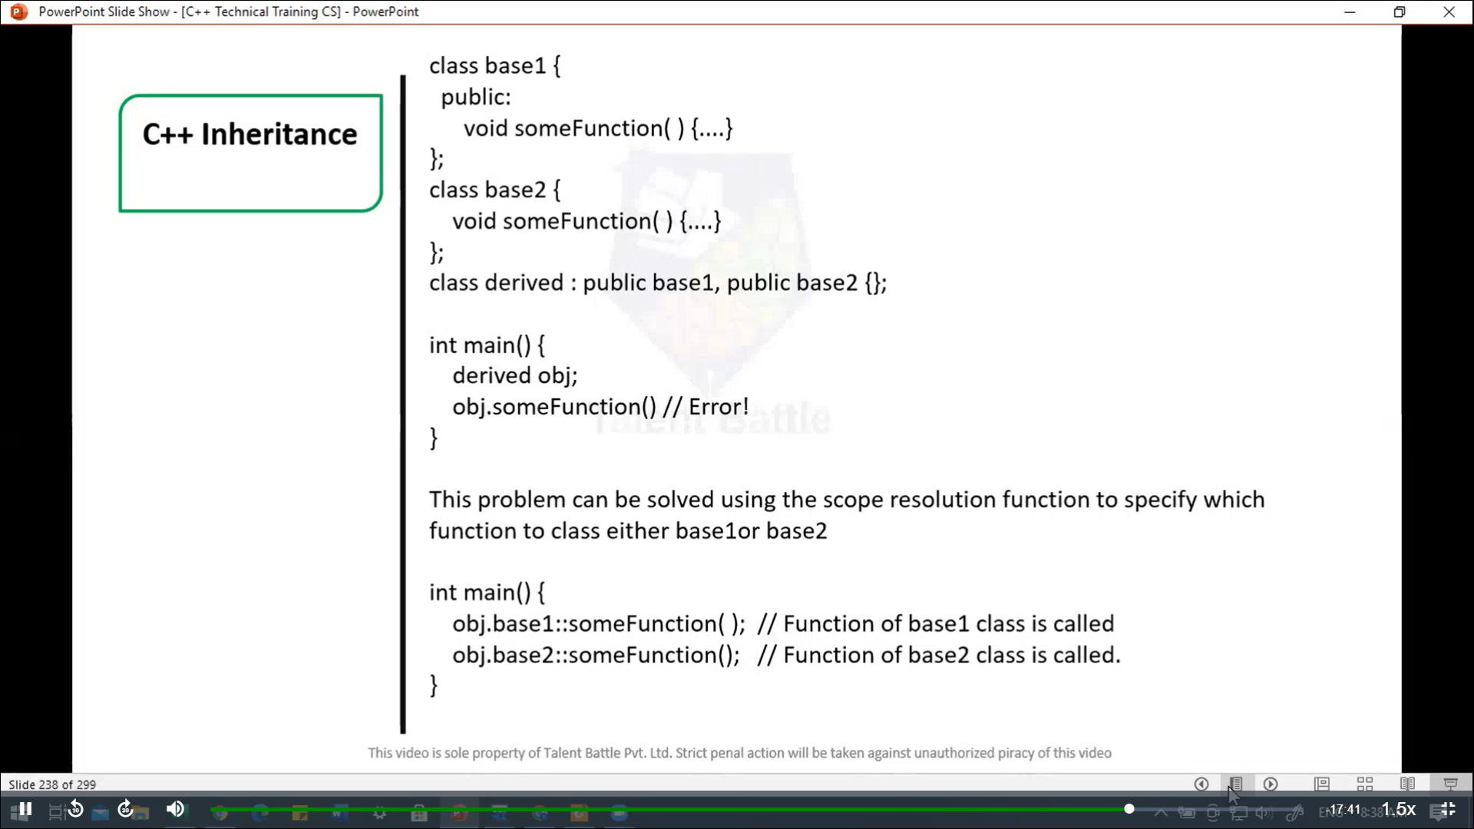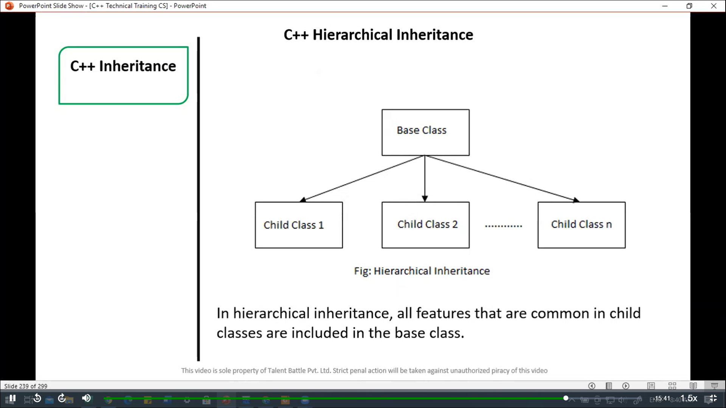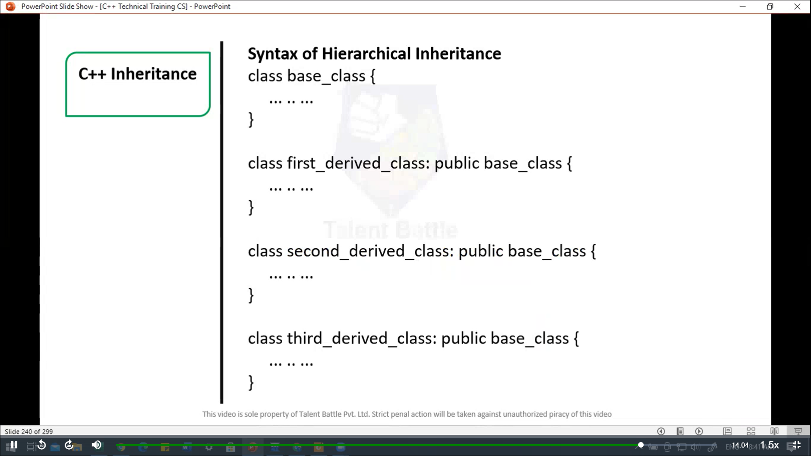

//======================================================

// C++ program to demonsrate hierarchical inheritance

#include<iostream>

using namespace ***std***;

// base class

*class* Animal{

  public***:***

    void *info*(){

      cout *<<* "I am an animal." *<<* *endl*;

    }

};

// derived class 1

*class* Dog ***:*** public Animal {

  public***:***

    void *bark*(){

      cout *<<* "I am a Dog. Woof woof." *<<* *endl*;

    }

};

// derived class 2

*class* Cat ***:*** public Animal{

  public***:***

    void *meow*(){

      cout *<<* "I am a Cat. Meow." *<<* *endl*;

    }

};

int *main*(){

  // Create object of Dog class

  Dog dog1;

  cout *<<* "Dog Class: " *<<* *endl*;

  dog1***.****info*(); // parent Class function

  dog1***.****bark*();

  // create object of Cat class

  Cat cat1;

  cout *<<* "**\n**Cat Class: " *<<* *endl*;

  cat1***.****info*(); // parent class function

  cat1***.****meow*();

  return 0;

}

/*

Dog Class:

I am an animal.

I am a Dog. Woof woof.

Cat Class:

I am an animal.

I am a Cat. Meow.

--------------------------------

Process exited after 0.1271 seconds with return value 0

Press any key to continue . . .

*/